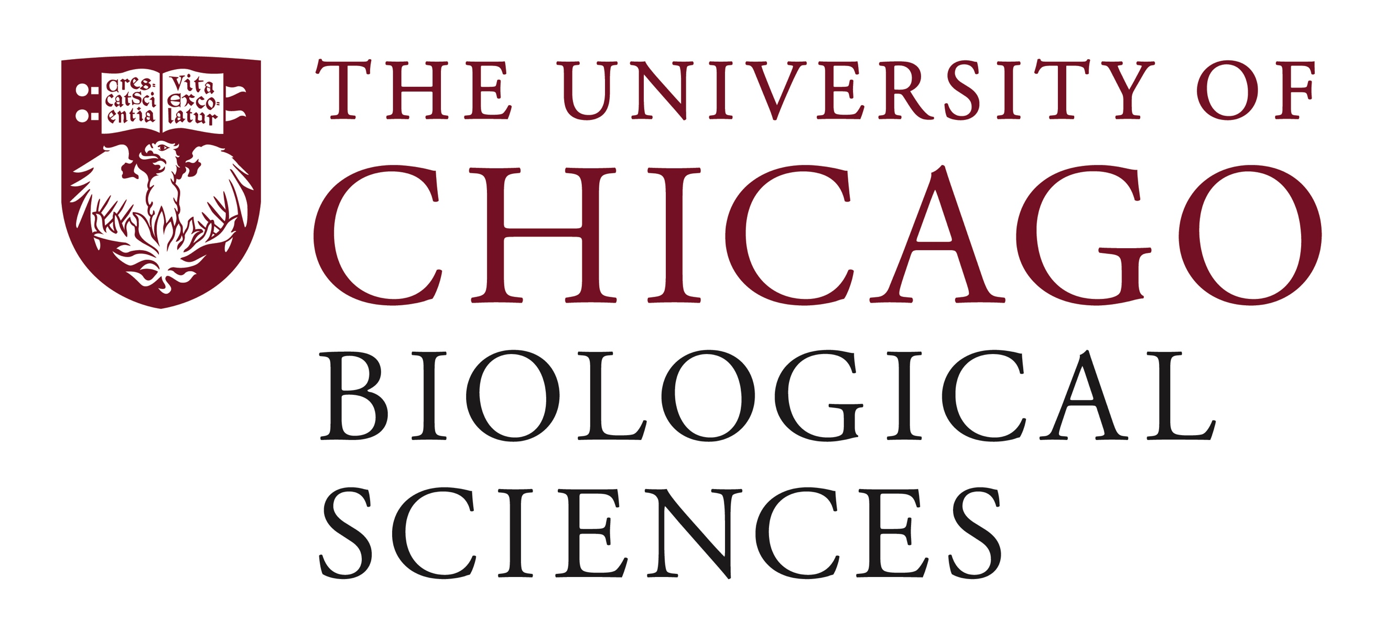

Postdoctoral Scholar Position Open in the Bader Lab.

Imaging Feedback for Histotripsy Ablation of Renal Tumors
The Biomedical Acoustics Development and Engineering Research Laboratory seeks a postdoctoral scholar in the field of image-guided focused ultrasound therapies for the treatment of renal tumors. The overall goal of this American Cancer Society-funded project is to develop an image-guided histotripsy technique for rapid ablation of renal cell carcinoma and neuroblastoma to decrease patient morbidity and mortality. This project will integrate technological advances in ultrasound imaging, computer vision, and advanced robotics to assist in the development of methods to improve clinical outcomes (e.g., efficacy, accuracy, and safety) of histotripsy ablation. The scholar will conduct in vitro and in vivo studies with high frame rate active and passive ultrasound imaging techniques to monitor bubble cloud activity initiated by the histotripsy source. Further information on the project can be found at baderlab.uchicago.edu.
A Ph.D. in biomedical engineering, physics, medical physics, or a related field is preferred. Proficiency in experimental and numerical techniques, and data acquisition and analysis are also required. The candidate must be highly motivated, have excellent written and verbal communication skills, and enthusiasm to work in a multi-disciplinary team. Preference will be given to candidates with demonstrated experience and productivity in ultrasound-guided therapies and cavitation dynamics. Mentorship by the principal investigator will be used for training and promoting career development of the candidate, and the scholar will also have the opportunity to collaborate with other basic and clinical scientists.
Motivated candidates should submit a curriculum vitae and cover letter addressing current research interests and dates of availability, and the names and contact information for three references via email to Dr. Kenneth Bader: baderk@uchicago.edu with the subject line “POSTDOC”. Compensation in the Biological Sciences Division follows the NIH NRSA Stipend scale. Additional information on benefits and being a postdoc in the University of Chicago Biological Sciences Division can be found at bsdpostdoc.uchicago.edu.
The University of Chicago is an Affirmative Action/Equal Opportunity/Disabled/Veterans Employer and does not discriminate on the basis of race, color, religion, sex, sexual orientation, gender identity, national or ethnic origin, age, status as an individual with a disability, protected veteran status, genetic information, or other protected classes under the law. For additional information please see the University's Notice of Nondiscrimination at: https://www.uchicago.edu/about/non_discrimination_statement/. Job seekers in need of a reasonable accommodation to complete the application process should call 773-702-6154 or email jhlavaty@radiology.bsd.uchicago.edu with their request.

