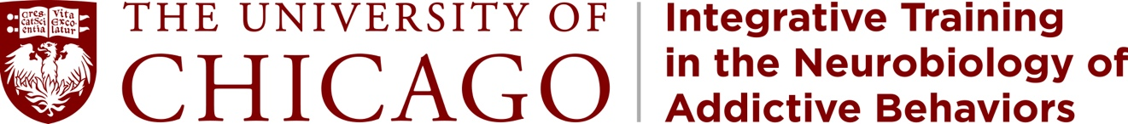

Post-Doctoral Training Opportunities in Addiction
NIDA T32 Training Grant
http://voices.uchicago.edu/addictiont32/

Join a dynamic, multidisciplinary training program at the University of Chicago. Our training program offers a wide range of opportunities in addiction research, from basic preclinical neuroscience to human behavior. Trainees acquire a range of experiences within their primary research area as well as through externships in other areas. Faculty research interests include cellular and molecular mechanisms (Xiaoxi Zhuang, Bill Green, and Ming Xu), synaptic, circuit and systems-level analyses (Dan McGehee, Mark Sheffield, Dan Margoliash, and Fred Garcia), human behavioral pharmacology, imaging and treatment (Harriet de Wit, Andrea King, Jon Grant, Dave Gallo, and Chin-Tu Chen) and public health, epidemiology and policy (Don Hedeker, John Schneider, and Harold Pollack). Our training grant brings together faculty and trainees from different disciplines to exchange views and participate in professional development and outreach.

The NIDA Training Program at the University of Chicago a lively cross-disciplinary intellectual environment that includes the Grossman Neuroscience Institute, Institute for Translational Medicine, human and animal behavioral laboratories, a drug abuse treatment program, and epidemiological and policy-related studies.

Post-doctoral candidates should contact the faculty member with whom they wish to work http://voices.uchicago.edu/addictiont32/ or submit a cover letter and curriculum vitae to Elena Rizzo <erizzo@uchicago.edu>. Appointments are usually for two years. Applicants must be US citizens or permanent residents.

