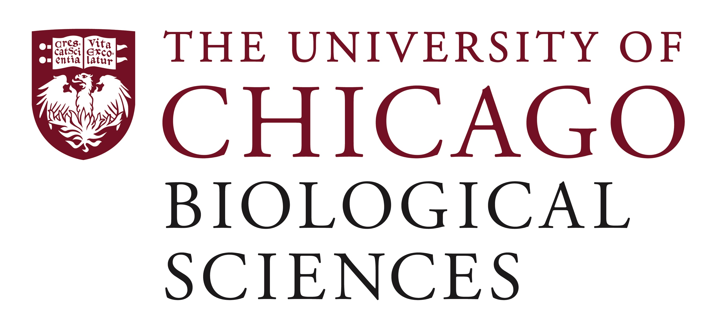

Postdoctoral Fellow Position Open in the Godley Laboratory

Inherited Predisposition to Hematopoietic Malignancies
We are seeking a postdoctoral researcher to test how often an inherited DNA deleterious variant drives the development of myelodysplastic syndrome (MDS). We have already shown that almost 20% of individuals diagnosed with MDS between the ages of 18-40 have a deleterious inherited DNA variant causing the disease, and now we want to expand the study to patients older than 40 years old. If this study demonstrates causative germline DNA variants across the age spectrum, then clinical standards for these patients may change by making germline predisposition testing standard practice for all patients regardless of the age at which they present with disease.
The postdoc will have the opportunity to work with primary bone marrow-derived mesenchymal stromal cells and their differentiated counterparts, including adipocytes, chondrocytes, and osteocytes; augmented whole exome sequencing and bioinformatic pipelines to call DNA variants; and collaborators across the world, including those working on our ClinGen Myeloid Malignancy Variant Curation Expert Panel.
Qualified applicants will have an M.D., and/or Ph.D. in Genetics, Molecular Biology, Biochemistry, or an associated field; expertise in tissue culture, DNA sequencing and analysis, and transcriptomic analysis.
Motivated candidates should submit a curriculum vitae and a statement of research goals to Dr. Lucy Godley at lgodley@uchicago.edu. Compensation in the Biological Sciences Division follows the NIH NRSA Stipend scale. Additional information on benefits and being a postdoc in the University of Chicago Biological Sciences Division can be found at bsdpostdoc.uchicago.edu.

