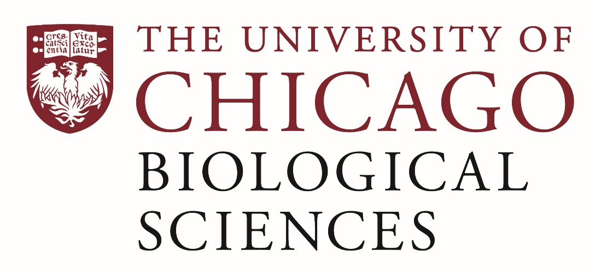

Postdoctoral Scholar Position Open in the Cardiac Electrophysiology Lab

The University of Chicago Departments of Medicine-Cardiology is recruiting a post-doctoral scholar to help conduct cardiovascular and electrophysiology study addressing molecular mechanisms of atrial fibrillation and microvascular dysfunction. The post-doctoral scholar will involve all aspects of the project including molecular biology, biochemistry, cardiovascular physiology, electrophysiology studies, imaging, histopathology, vascular biology and cellular analysis. She/He needs to be instrumental in performing experiments and possesses skills and experience in scientific data collection, analysis and interpretation. She/He will work directly with Dr. Cevher Ozcan to complete the project.

Applicants should have an MD, or PhD or at least be all but dissertation (ABD). Experience with basic science research is required. Strong interpersonal skills and demonstrated research experience are also required. Experience with cardiovascular research, cellular electrophysiology, and animal models of diseases is highly desired.

Motivated candidates should submit a curriculum vitae and a statement of research goals to Dr. Cevher Ozcan at cozcan@medicine.bsd.uchicago.edu. Compensation in the Biological Sciences Division follows the NIH NRSA Stipend scale. Additional information on benefits and being a postdoc in the University of Chicago Biological Sciences Division can be found at bsdpostdoc.uchicago.edu. The University of Chicago is an Affirmative Action/Equal Opportunity Employer.

The successful applicant will begin January 2022.

