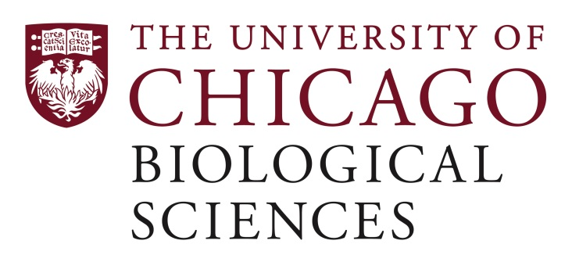

Postdoctoral Scholar Position Open in the LaBelle Lab.

[Pediatric Hematology Oncology and Stem Cell Transplantation]
A postdoctoral position is available in the laboratory of Dr. James LaBelle in the Department of Pediatrics, Section of Hematology/Oncology/Stem Cell Transplantation in the Division of Biological Sciences at the University of Chicago. Dr. LaBelle’s research examines the use of novel therapeutics (small molecule and peptide-based) and other molecular tools to dissect and pharmacologically target the intrinsic apoptotic pathway and regulatory machinery to manipulate the immune response. We are interested in the translation of such therapies to patients undergoing adoptive T cell-mediated therapies and stem cell transplantation. The laboratory uses collaborative chemical biology, traditional molecular biology methods, cellular biochemistry, murine xenograft models of disease, and microscopic imaging to discover novel targets and drug mechanisms of cell death.
We seek a motivated, creative, and energetic applicant to work on translational immunologic applications for novel therapeutics targeting immune cells including those for adoptive therapies. The work would be also be associated with other areas of research in our lab targeting the BCL-2 family of apoptotic proteins. These include synthesis and intracellular delivery of peptide and small molecule therapeutics to cancer cells along with human and murine immune cells in the context of graft-versus-host disease, anti-tumor immunity, and adoptive T cell therapies. The specific details of the project(s) can be flexible to accommodate the interests of the successful applicant.
The postdoc will have the opportunity to work with laboratories in the Departments of Medicine and Chemistry and the Center for Translational Data Science, Institute for Genomics and Systems Biology, the Pritzker School of Molecular Engineering, and Computational Research Institutes at the University of Chicago.
Candidates must have a Ph.D. and/or M.D., or equivalent. Priority will be given to qualified candidates with a strong background in tumor immunology, transplantation biology, expression profiling/data analysis, biochemistry, flow cytometry, and BCL-2 family cell death-related research. Experience with mice is also preferred but not required. Competitive applicants will have a proven track record in terms of publications and independent funding.
Motivated candidates should submit curriculum vitae, names and contact information of three references, and a cover letter summarizing your research interests and future career aspirations (one page limit) to Dr. James LaBelle at jlabelle@peds.bsd.uchicago.edu
Compensation in the Biological Sciences Division follows the NIH NRSA Stipend scale. Additional information on benefits and being a postdoc in the University of Chicago Biological Sciences Division can be found at bsdpostdoc.uchicago.edu.

