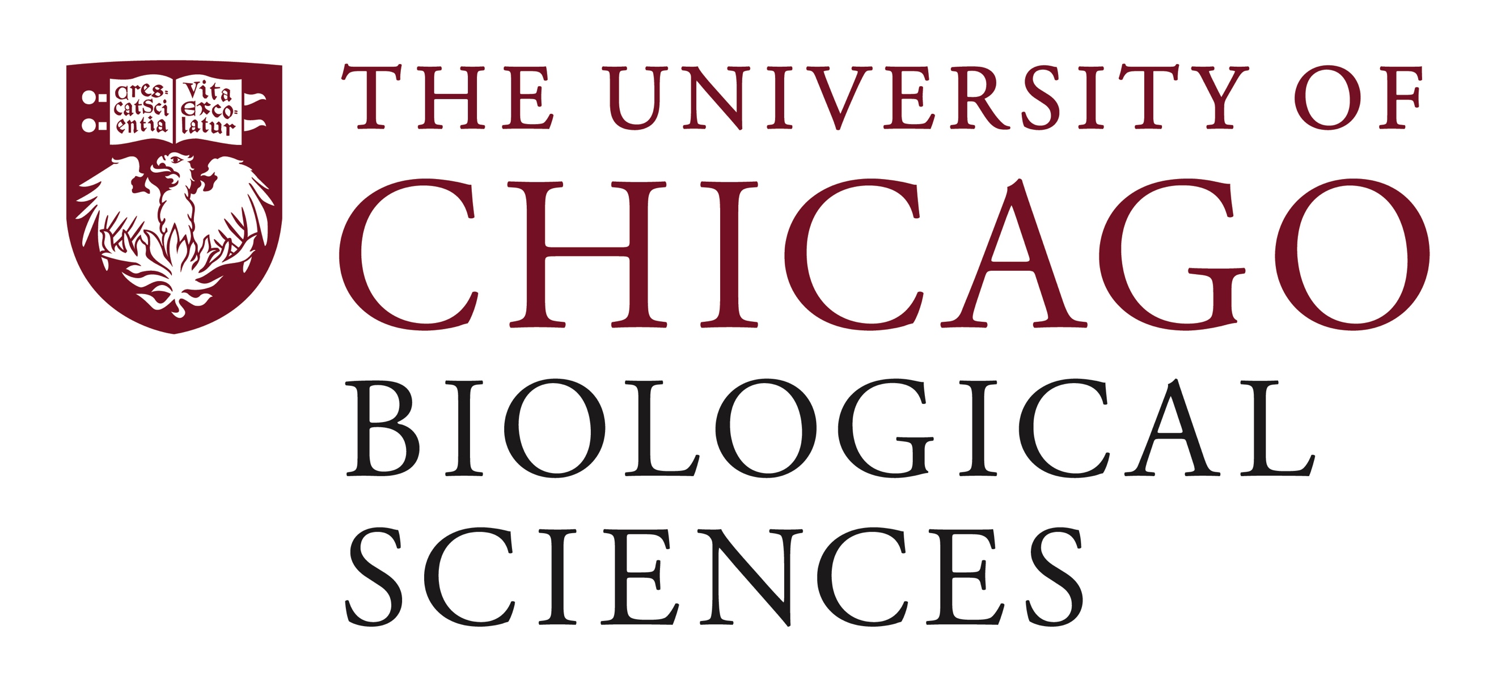

Postdoctoral Scholar Position Open in the Neurovascular Research Lab in the Department of Neurological Surgery.

The Neurovascular Research Laboratory in the Department of Neurological Surgery at the University of Chicago Medicine and the Division of Biological Sciences seeks applicants for a post-doctoral position to support the identification and development of circulating and imaging biomarkers (on-going project funded by NIH/NINDS) in a research program with a focus on translational medicine. The Neurovascular Surgery Research Program is a translational research unit, funded by the NIH and other sources, and engaged in national and international collaborative projects.
The Neurovascular Research team includes scientists from different disciplines, focusing on mechanisms of genesis of vascular malformations of the brain, biomarkers of disease in human subjects and preclinical mouse models, and clinical trials of novel interventions for vascular malformations and hemorrhagic stroke.
The candidate will have the opportunity to work and collaborate with clinical and basic scientists from a range of disciplines including radiology, neurosurgery, neurology, and related disciplines. The candidate will be mainly working with human and mouse plasma samples in a team-oriented environment.
We encourage women and minority applicants through our commitment to enhance diversity of the work environment.

https://bsd-neurosurgery.prod.uchicago.edu/research/neurovascular-surgery-research
Essential Functions:
Main duties in this position will include:

- Performing assessments and data analyses of circulating plasma compounds (i.e., proteins, metabolites, and miRNome) in patients as well as preclinical mouse model
- Performing single cells isolation of human and mouse brain tissue
- Assisting with data analyses using Machine Learning and Bayesian Statistical Approaches
- Writing scientific reports and grant drafting
- Presenting during scientific conferences and workshops
Other responsibilities may include assisting with MRI acquisition from human subjects; imaging tissue from human subjects and animal models; managing data files and clinical database; following established procedures or protocols; and collaborating with other university labs.

Qualifications:
Education:
Required:
- PhD in relevant field required (neuroscience, biology, or related)

Experience:
Required:
- Performed ELISA assays and PCR
- Performed RNA and DNA extraction
- Experienced in single-cell isolation

Preferred:
- Experienced in handling large datasets
- Experienced in advanced statistical analyses
- Experienced in clinical and translational human research as it is applied to biomarkers in proof of concept and clinical trials preferred
- Experienced in handling preclinical animal models
- A history of peer-reviewed publications related to field of study preferred

Candidate Competencies:
- Advanced knowledge in relevant scientific field required
- Advanced knowledge of research techniques or methods required
- Knowledge of regulatory policies and procedures required
- Problem-solving skills required
- Attention to detail required
- Organizational skills required
- Ability to learn new research techniques or methods required
- Ability to work independently and as part of a team required
- Familiarity with grant preparation preferred
- Knowledge of Microsoft Office required
- Analytical skills required
- Strong verbal and written communication skills required
- Knowledge of scientific applications and equipment preferred
- Ability to train others preferred

Motivated candidates should submit a curriculum vitae and a statement of research goals to Dr. Issam Awad at iawad@bsd.uchicago.edu. Compensation in the Biological Sciences Division follows the NIH NRSA Stipend scale. Additional information on benefits and being a postdoc in the University of Chicago Biological Sciences Division can be found at bsdpostdoc.uchicago.edu.

