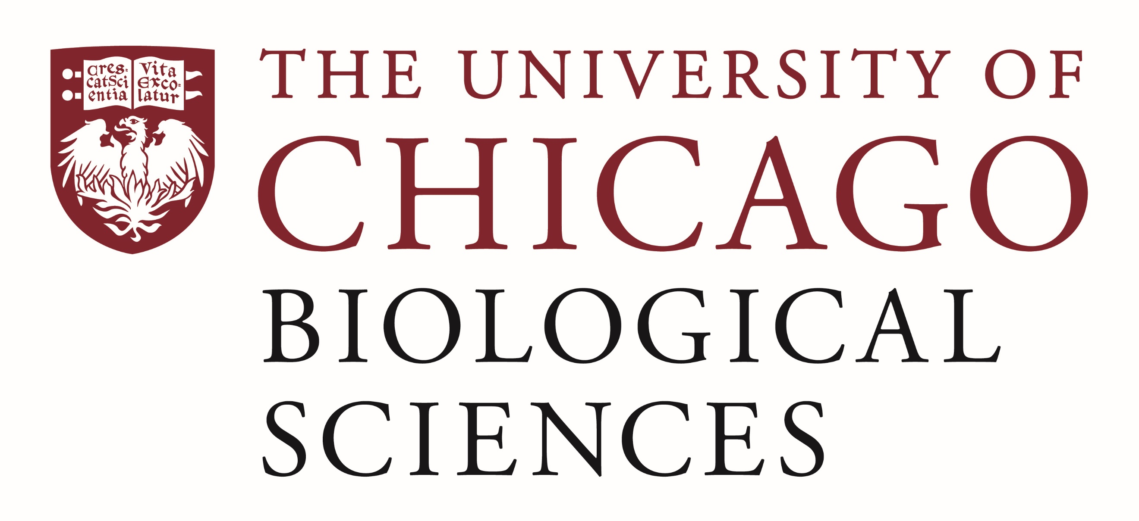

Postdoctoral Scholar Position Open in the Laboratory for Molecular Regeneration.

Hyaluronan Biochemistry and Biophysics
Under the direction of Dr. Lee, Professor and PI in the Department of Surgery, the incumbent will assume responsibility for investigating the chemical properties and content of glycosaminoglycans, especially hyaluronan, in various adipose tissues. The plan is to use sensitive immunoassay methods such as ELISA, AlphaLisa, and chromotraphic methods. The biophysical role of hyaluronan in controlling the thermal stability of adipose tissue proteins, especially small molecular weight enzymes, is a question that we are starting to investigate. Historically, our laboratory has focused on defining the capability of synthetic multi-block copolymers to mimic some behaviors of small molecular weight natural molecular chaperones. We postulate that certain glycoprotein manifest similar behavior.
Qualifications:
A doctorate degree in Biochemistry, Biophysics, Biomedical Engineering, or molecular biology is required. Experience in glycoprotein biochemistry is preferred. A working knowledge of the analytical biochemistry method listed above, and others used in connective tissue research, cell and tissue culture methods, quantitative light microscopy methods, molecular imaging, immunoassay, and related methods would be highly valued. Furthermore, interest to learn new assay techniques could be important.
In general, the ability to work both independently and as an integral part of a team is important. Good task organizational skills, strong written and verbal communications skills, and data analysis skills are required. Our research group has daily contact with fellows, students, and faculty from Surgery and other sections. In addition to doctoral level scholarship, the desired individual will need to possess ability to overcome research challenges and the skills of analysis, writing, and coordination.
The above statements are intended to describe the general nature and level of the work being performed by people assigned to this job. They are not an exhaustive list of all duties and responsibilities associated with it.
Principal Duties and Responsibilities:
- Specific to Hyaluronic Acid Studies:
- Setup and calibrate an ELISA (or similar) system for detecting hyaluronic acid in adipose tissue;
- Use HPLC, DSC, CD methods or similar to determine molecular weight and perhaps compositional distribution of HA in adipose tissue;
- Determine HA’s ability to catalyze refolding of thermally denatured proteins using various biophysical assays;
- Oversee and instruct students performing various research projects;
- Oversight of undergraduate and graduate students;
- Assist in maintaining our cell culture facility;
- Determine variation of HA content of adipose tissue located in different regions of the face;
- Data processes and analysis.

- Other duties and responsibilities:
- Review and edit scientific manuscripts, and provide general writing support and editing support for abstracts, journal articles, book chapters, grant reports and other research oriented documents;
- Attend professional conferences and meetings and review published literature to keep abreast of developments in biomedical research, as well as those dealing with grant and contract opportunities and the changing environment for research;
- Collaborate with supervisor(s) / administration to establish goals for self-development, for continual assessment and to evaluate personal knowledge;
- Oversee undergraduate and medical students in the performance of their research; and
- Participate in the structured graduate educational programs established for postdoctoral students.

Motivated candidates should submit a curriculum vitae and a statement of research goals to Dr. Lee at rlee@surgery.bsd.uchicago.edu. Compensation in the Biological Sciences Division follows the NIH NRSA Stipend scale. Additional information on benefits and being a postdoc in the University of Chicago Biological Sciences Division can be found at bsdpostdoc.uchicago.edu.

