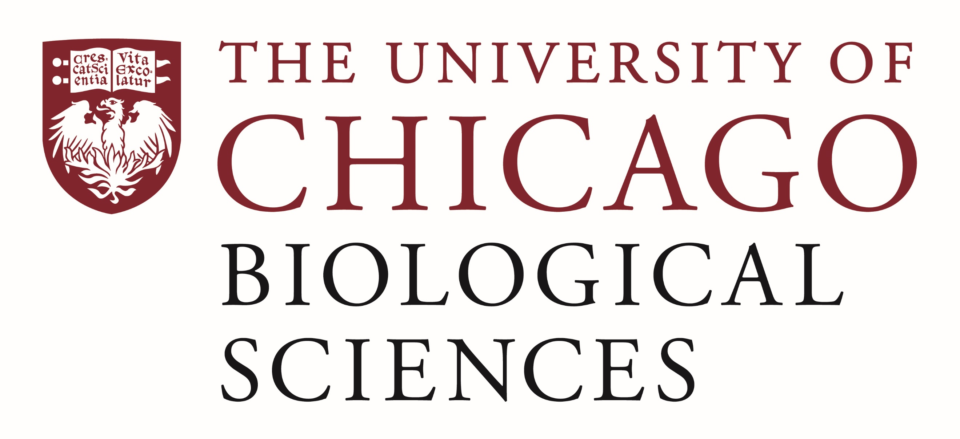

Postdoctoral Scholar Position Open in the Lainie Ross Lab

The University of Chicago departments of pediatrics and medicine are recruiting for a one-year NIH-funded post-doctoral scholar to help conduct a qualitative study addressing the return of research results to participants in a multi-center NIH-funded study that aims to discover and define rare and atypical forms of diabetes (RADIANT: https://www.atypicaldiabetesnetwork.org/)

The scholar will be involved in all stages of the project. He/she will be responsible for recruitment of RADIANT participants and investigators. He/she will audiotape and transcribe all of the interviews and conduct the RADIANT participant health literacy questionnaires and the RADIANT investigator knowledge/experience with phenotyping procedures and results. He/she will help in coding, developing the coding tree, theme generation and analysis, and help in the writing and revisions to manuscripts.

Applicants should have an MD, JD, or PhD or at least be all but dissertation (ABD). Experience with qualitative research is required. Strong interpersonal skills and demonstrated research experience are also required. Experience with qualitative coding software (e.g., Atlas.ti) is highly desired.

Motivated candidates should submit a curriculum vitae and a statement of research goals to Dr. Lainie Ross at lross@peds.bsd.uchicago.edu. Compensation in the Biological Sciences Division follows the NIH NRSA Stipend scale. Additional information on benefits and being a postdoc in the University of Chicago Biological Sciences Division can be found at bsdpostdoc.uchicago.edu. The University of Chicago is an Affirmative Action/Equal Opportunity Employer.

The successful applicant will begin August 2021.

