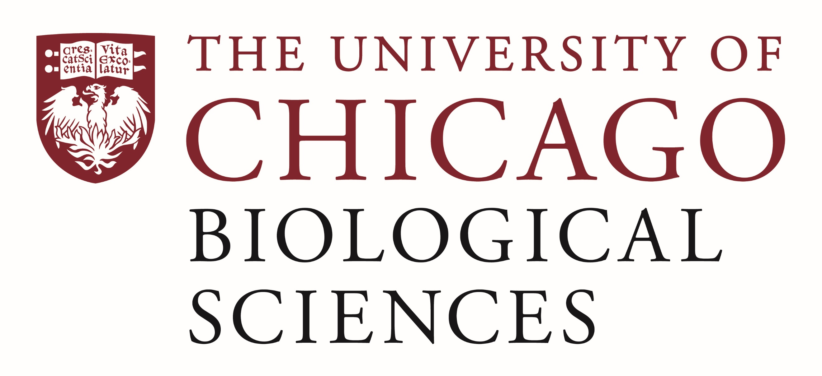

Postdoctoral Scholar Position Open in Dr. Ciaccio’s Lab.

Clinical Translational Research
We are seeking a postdoctoral researcher to work on a project investigating the association of how the microbiome influences oral immunotherapy to peanut. Dr. Ciaccio’s team is working on innovative prevention, diagnostic and therapeutic techniques to advance the practice of food allergy and asthma.
The postdoc will have the opportunity to work with the University of Chicago Allergy/Immunology physicians, nurses and research coordinators on aspects of clinical trial administration, clinical sample preparation, storage, and grant/manuscript writing.
Excellent communication and organization skills are a must. Interested candidates should have an interest in both patient care and clinical/translational research.

Motivated candidates should submit a curriculum vitae and a statement of research goals to Dr. Ciaccio at cciaccio@bsd.uchicago.edu . Compensation in the Biological Sciences Division follows the NIH NRSA Stipend scale. Additional information on benefits and being a postdoc in the University of Chicago Biological Sciences Division can be found at bsdpostdoc.uchicago.edu.

