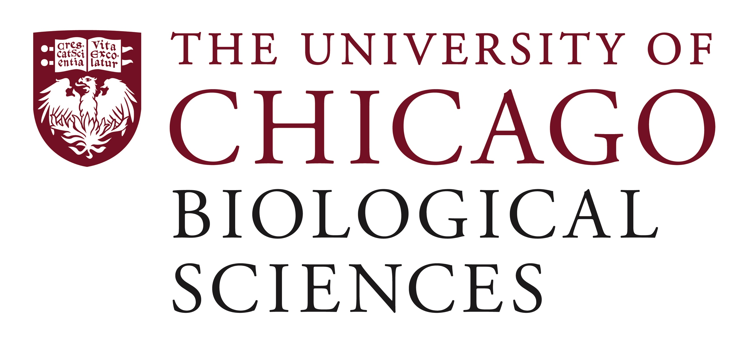

Postdoctoral (Scholar or Fellow) Position Open in the Connell Lab.

The Connell Lab (https://www.uchicagomedicine.org/find-a-physician/physician/philip-connell) is seeking a diligent and enthusiastic colleague at the postdoc level to join our efforts in studying mechanisms that promote treatment resistance in tumors and in developing new anti-cancer agents to overcome these malignant features. A central focus of the lab is the development of novel drugs that can reduce DNA repair proficiency in tumors, thereby sensitizing tumors to existing DNA-damaging therapies.
High-throughput screening programs have been employed in our lab to identify drug candidates capable of inhibiting such processes. Our newer projects are focused on agents that can target upstream signaling pathways that promote aberrant expression of DNA repair proteins in cancers.
The postdoc will have the opportunity to work in a multi-disciplinary environment in close collaboration with translational scientists, as well as molecular and systems biologists at the University of Chicago.
Job Requirements: PhD or equivalent doctoral degree in systems biology, molecular biology, cancer biology, biochemistry, chemical or biomedical engineering; a strong record of scientific achievement through publications and presentations, as well as a passion for translational science; excellent written and spoken communication skills in English; ability to conduct research independently with strong wet lab skills. Successful postdocs are generally able to work well in a team environment. Additionally, experience with flow cytometry, immunofluorescence microscopy, molecular biology techniques, cell culture, murine tumor models, and bioinformatics are preferred.
Motivated candidates should submit a curriculum vitae, a brief statement regarding research interests, and a list of 2-3 references with their email addresses to Dr. Philip Connell at pconnell@radonc.uchicago.edu. Compensation in the Biological Sciences Division follows the NIH NRSA Stipend scale. Additional information on benefits and being a postdoc in the University of Chicago Biological Sciences Division can be found at bsdpostdoc.uchicago.edu. The University of Chicago is an Affirmative Action/Equal Opportunity/Disabled/Veterans Employer and does not discriminate on the basis of race, color, religion, sex, sexual orientation, gender identity, national or ethnic origin, age, status as an individual with a disability, protected veteran status, genetic information, or other protected classes under the law.

