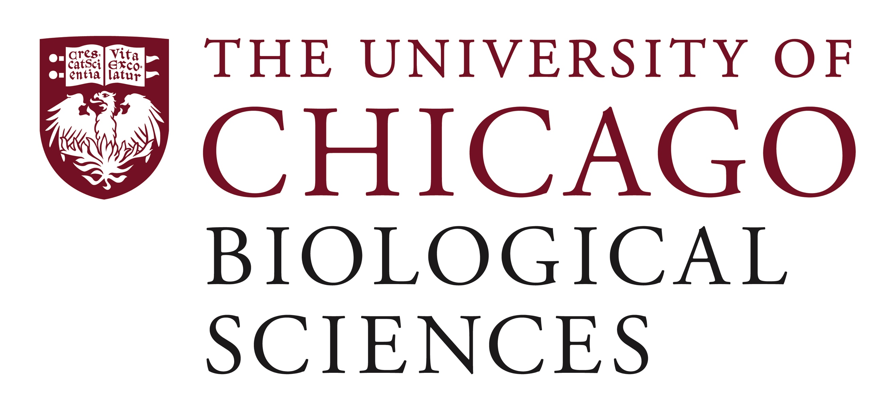

Postdoctoral (Scholar or Fellow) Position Open in the laboratory of David Wu in single cell metabolism.

Area of expertise: super resolution microscopy, biophysics, metabolism, endothelial cells and mechanotransduction
We are seeking a postdoctoral researcher to work on single cell metabolism. The lab’s overall research goal is to understand the regulation of endothelial barrier function from a metabolism perspective. We are located within the Department of Medicine, in the Section of Pulmonary and Critical Care. This particular project seeks to understand, but is not limited to, the structural foundation of energy regulation in endothelial barriers using super resolution microscopy (pointillist) techniques. Please visit https://wulab.uchicago.edu.
The postdoc will have the opportunity to work closely with collaborators such as Prof. Yun Fang and Prof. Gokhan Mutlu.
Qualifications: willing to learn (or familiar with) microscopy and image analysis, and familiarity with cell biology/molecular biology techniques. Ability to conduct independent research. Qualified candidates should have a PhD in a related field with quantitative background, preferred.
Motivated candidates should submit a curriculum vitae to Dr. David Wu at dwu1@medicine.bsd.uchicago.edu or call me at 773-702-6575. Compensation in the Biological Sciences Division follows the NIH NRSA Stipend scale. Available opportunity (but not exclusive) to join the Respiratory Biology T32 or Cardiovascular T32 postdoctoral training grants. Additional information on benefits and being a postdoc in the University of Chicago Biological Sciences Division can be found at bsdpostdoc.uchicago.edu.

