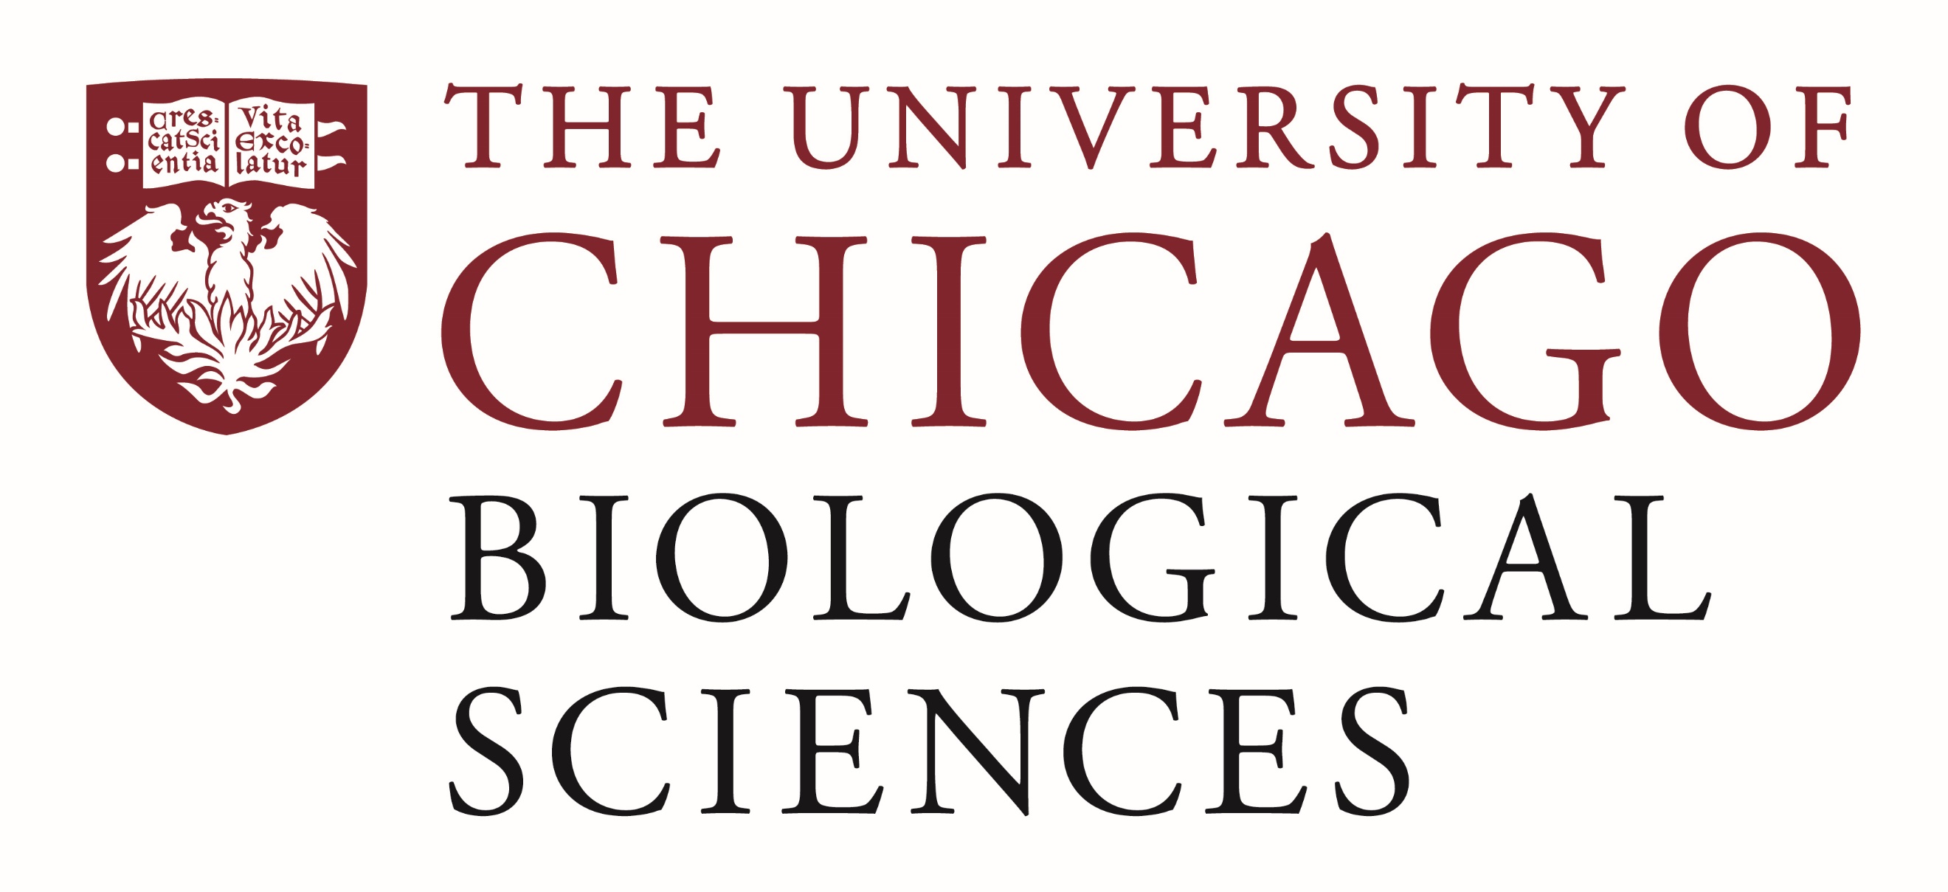

Postdoctoral Position Available
Tumor Immunology and Immunotherapy Research
University of Chicago Comprehensive Cancer Center
Location: Chicago, IL

Job Description:
A Postdoctoral Fellow/Associate position is available in the laboratory of Dr. Kunle Odunsi at the University of Chicago Comprehensive Cancer Center and the Department of Obstetrics and Gynecology at the University of Chicago. The primary research area focuses on studying the mechanisms of tumor immune recognition and resistance to immunotherapy. The candidate will have the opportunity to work in a multi-disciplinary environment in close collaboration with translational scientists, molecular and systems biologists, and clinicians at the University of Chicago.
Required qualifications: PhD or equivalent doctoral degree with background in immunology, molecular biology, or cancer biology, a record of scientific achievement through publications and presentations, a passion for translational science; excellent written and spoken communication skills in English; and ability to conduct research independently with strong wet lab skills. Additionally, experience with flow cytometry, molecular biology techniques, cell culture, murine tumor models, and bioinformatics are preferred. This position will be expected to demonstrate independence in experimental design and execution, work effectively with others in a collaborative setting, present results at both national and international meetings, and ultimately publish results.

Interested candidates should submit a curriculum vitae, a brief statement regarding research experience and interests, and a list of 2-3 references with their email addresses to adapistello@bsd.uchicago.edu. Compensation in the Biological Sciences Division follows the NIH NRSA Stipend scale. Additional information on benefits and being a postdoc in the University of Chicago Biological Sciences Division can be found at bsdpostdoc.uchicago.edu.
The University of Chicago is an Equal Opportunity/Affirmative Action Employer. All qualified applicants will receive consideration for employment without regard to race, color, religion, sex, sexual orientation, gender identity, national origin, age, protected veteran status or status as an individual with disability.

