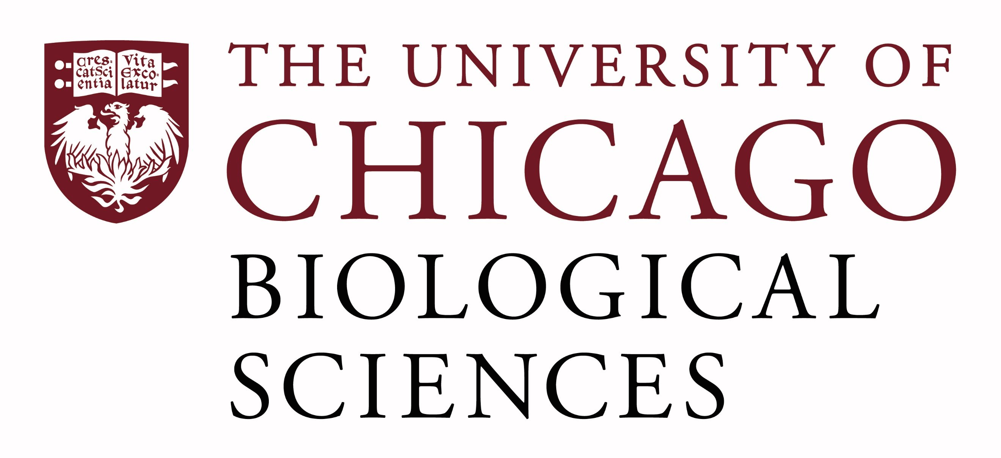

Postdoctoral Position Open in the Malamy Lab.

Cell Biology and Wound Healing in a Cnidarian model system
We are seeking a postdoctoral researcher to work on the cell:matrix interactions during epithelial wound healing. Our lab has pioneered the use of the medusa (jellyfish) stage of Clytia hemisphaerica to study cell migration and wound healing in vivo. This project is focused on signaling between cells and the extracellular matrix during healing in Clytia. Please visit our website for more information on our work. https://voices.uchicago.edu/jocelynmalamylab/
Successful applicants will have a Ph.D. in Cell Biology or related field.
Interested candidates should submit a curriculum vitae and a statement of research goals to Dr. Malamy at jmalamy@bsd,uchicago.edu. Compensation in the Biological Sciences Division follows the NIH NRSA Stipend scale. Additional information on benefits and being a postdoc in the University of Chicago Biological Sciences Division can be found at bsdpostdoc.uchicago.edu.

