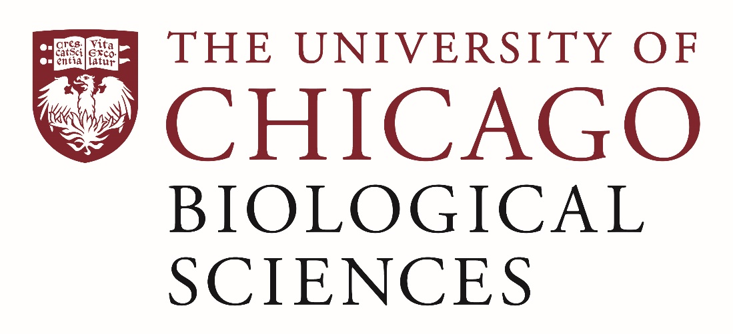

Postdoctoral (Scholar or Fellow) Position Open in the Hale Lab.

Neuroscience and Behavior
We are seeking a postdoctoral researcher to work on sensorimotor physiology and neural circuits that drive movement. The Lab uses zebrafish, other fish models and octopus to examine mechanosensation and motor control of limb movement and locomotor behaviors. The lab aims to understanding the organization and function of sensorimotor circuits that control movement and how they evolve and develop.
The postdoc will have the opportunity to work with collaborators in biomechanics, behavior and engineering and in core imaging facilities at the University of Chicago. The project integrates neurophysiology with neuroanatomy, behavior and experimental perturbation providing opportunities to learn a range of research approaches.
The candidate should have expertise in single cell physiology recording and analysis and have worked with organisms, preferably zebrafish. The candidate should be interested in developing new physiology preparations and using molecular approaches to probe neural circuits. The candidate should have experience and interest in mentoring students, particularly undergraduates, in research and will need to work with the PI and other lab members on lab maintenance and oversight.
Motivated candidates should submit a curriculum vitae and a statement of research goals to Dr. Melina Hale at mhale@uchicago.edu. Compensation in the Biological Sciences Division follows the NIH NRSA Stipend scale. Additional information on benefits and being a postdoc in the University of Chicago Biological Sciences Division can be found at bsdpostdoc.uchicago.edu.

