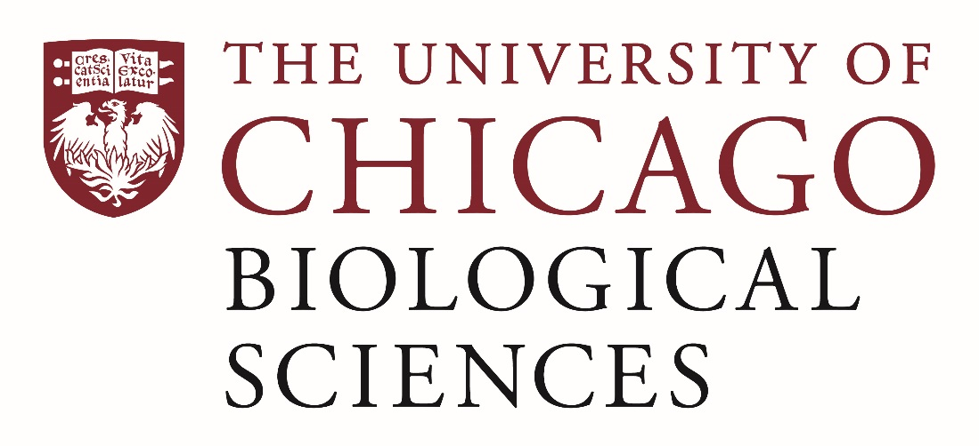

Postdoctoral (Scholar or Fellow) Position Open - Peter Savage Lab.

[Endogenous immune responses to carcinogen-induced oral cancer]
The laboratory of Dr. Peter Savage in the Department of Pathology at the University of Chicago is seeking a postdoctoral researcher to study the endogenous immune reponse to cancer in a mouse model of carcinogen-induced oral squamous cell carcinoma. The Savage Laboratory studies fundamental mechanisms of endogenous anti-tumor immunity and the response to immune-based therapy. We are looking for a highly motivated scientist to lead a project exploring the mechanisms impacting tumor development and progression in this model.

The postdoc will have the opportunity to work with many talented collaborators across the University of Chicago and its Biological Sciences Division (https://biologicalsciences.uchicago.edu/), including within the Department of Pathology (https://pathology.uchicago.edu/), the UC Comprehensive Cancer Center (https://cancer.uchicago.edu/), and the Committee on Immunology (https://immunology.uchicago.edu). This individual will be closely mentored by the Principal Investigator to advance her/his career in biomedical research.
Applicants should have a recent Ph.D. in Immunology, and prior expertise in the study of immunity to carcinogen-induced oral cancer in mice. Excellent writing skills and proficiency in English are required. Basic knowledge of immunology, cancer biology, cell signaling, mouse models, and tissue immunohistochemical evaluation preferred.
Motivated candidates should submit a curriculum vitae and a statement of research goals to Dr. Peter Savage at psavage@bsd.uchicago.edu. Compensation in the Biological Sciences Division follows the NIH NRSA Stipend scale. Additional information on benefits and being a postdoc in the University of Chicago Biological Sciences Division can be found at bsdpostdoc.uchicago.edu.

