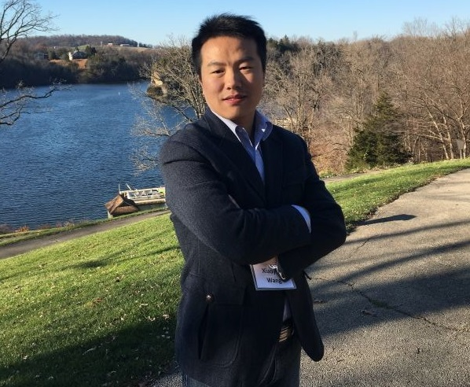
Xiaoyun (Sean) Wang, PhD, a Postdoctoral Scholar in the Pan Lab, and was recently promoted to Pathways to Independence Instructor and was awarded a K01 from the NIDDK. Kristy Hentchel, PhD, former Postdoc Press editor and current AAAS ST&P Fellow interviewed Sean for this month’s Postdoc Spotlight.

Q: What is your research focus?
A: My postdoctoral research in the University of Chicago focuses on RNA epigenetics in human diseases such as cancers and digestive diseases. Specifically, I am studying RNA modifications on tRNA molecules which are key factors during protein synthesis. My projects involve identification and characterization of new tRNA modifications that can affect human health at molecular level. We employ high throughput sequencing technology to identify the consequences of RNA modifications in gene expression. I also perform various validation experiments to test the role of RNA modifications in controlling phenotypic changes at cellular and tissue level. My graduate work focused on pathogen biology to investigate the mechanisms by which human pathogens cause liver diseases. I also participated in the development of human vaccines to prevent these liver pathogens.

Q: Which K award did you receive? What was the process like (writing the grant, the review process, etc)?
A: I received a K01 award from National Institute of Diabetes and Digestive and Kidney Diseases (NIDDK) at National Institutes of Health. The purpose of the NIDDK K01 award is to provide an intensive, supervised, research and career development experience for postdoctoral researchers as they transition to independent careers. I submitted my application in November 2016, and my application was reviewed with a nice score in March 2017. In the meanwhile, NIH requested the Just-in-Time information. I received the official Notice of Award from NIH at the beginning of August 2017.

Q: What do you enjoy most about working in lab?
A: The most rewarding and enjoyable aspect of working in lab is that I can connect my research with human health issues, because during my research I can use the knowledge from my clinical medicine degree. I enjoy applying my research discovery results to help understand the mechanisms of human diseases and I am trying to develop new biomarkers for human health issues.

