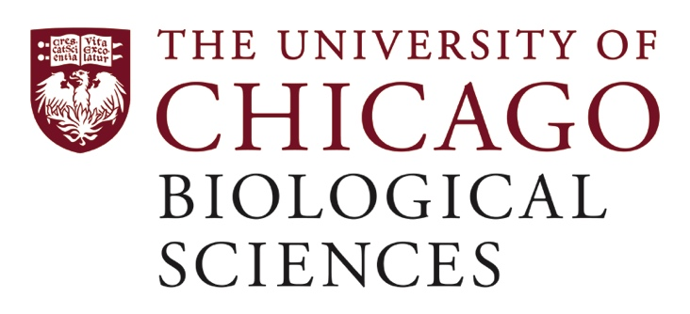

Postdoctoral Scholar Position Open in the Sara Szuchet, D. Phil. Lab.

Cell/molecular biology; cellular/molecular neuroscience

We are seeking a postdoctoral researcher to work on the biology of oligodendrocytes and the molecular mechanism of myelin sheath assembly. We have recently challenged the 50-year-old dogma that the myelin sheath is no more than a modified version of oligodendrocyte plasma membrane by showing that: i) myelin membranes are synthesized as independent structural entities; ii) are packaged into novel organelles that we have named “myelinophores”; iii) they generate the myelin sheath by stochastic fusion; and iv) the myelin sheath resides within the oligodendrocyte process; i.e., facing the axolemma is the plasma membrane of the oligodendrocyte process. These novel and cardinal concepts call for thinking anew about the basic biology of oligodendrocytes and the factors that are at play in the formation of the myelin sheath and about its pathological destruction. Indeed, the time is ripe for a fundamental change in paradigm on these important problems. Current research aims are to: 1) characterize, biochemically and structurally, the myelinophore organelles with particular emphasis on the manner they deliver their cargo – the myelin membrane tubules; 2) investigate the mechanism of myelin membrane fusion; 3) demonstrate that there is interaction between the axolemma and the oligodendrocyte plasma membrane in the formation of the Nodes of Ranvier and define the nature of this interaction.
https://voices.uchicago.edu/saraszuchet

The postdoc will have the opportunity to work with collaborators in the fields of microfluidic, live imaging; cryo-electron tomography & electron microscopy core facility
The successful candidate is expected to hold a Ph.D. degree with a good background in neuroscience, cell biology, biochemistry and structural biology. Hands-on experience with immunological and imaging techniques, electron microscopy and modeling would be an advantage. This position requires an individual with a strong passion for research; someone who is not afraid to face challenges and is willing to contest long-standing believes.
Motivated candidates should submit a curriculum vitae and a statement of research goals to Dr. Sara Szuchet at szuchet@neurology.bsd.uchicago.edu. Compensation in the Biological Sciences Division follows the NIH NRSA Stipend scale. Additional information on benefits and being a postdoc in the University of Chicago Biological Sciences Division can be found at bsdpostdoc.uchicago.edu.

