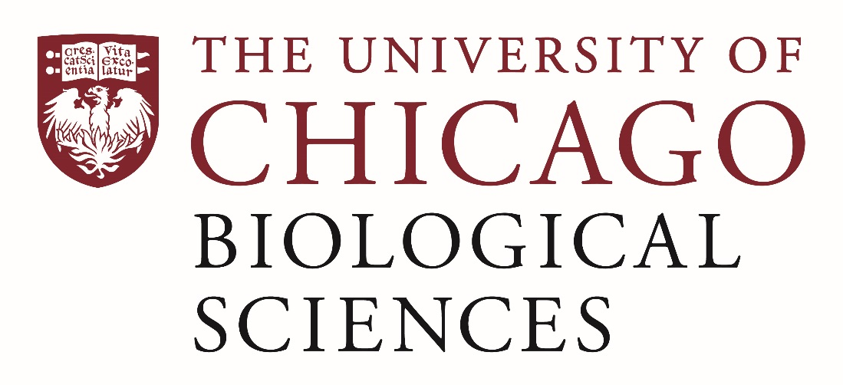

Postdoctoral (Scholar or Fellow) Position Open in the Oakes Lab.

[Cancer Cell Signaling]
The laboratory of Professor Scott Oakes is moving to the University of Chicago it the Summer of 2019 and seeking a postdoctoral researcher to work on the role of an ancient survival pathway called the Unfolded Protein Response (UPR) in cancer. The Oakes Laboratory studies fundamental mechanisms of cell survival and death in diseases ranging from cancer to neurodegeneration. We are looking for a highly motivated scientist to lead a project exploring the role of the UPR in neuroendocrine tumors and other cancer types, using cell lines, mouse models and human tumor specimens.

The postdoc will have the opportunity to work with many talented collaborators across the University of Chicago and its Biological Sciences Division (https://biologicalsciences.uchicago.edu/), including within the Department of Pathology (https://pathology.uchicago.edu/), the UC Comprehensive Cancer Center (https://cancer.uchicago.edu/), and the Institute for Molecular Engineering (https://ime.uchicago.edu/). This individual will be closely mentored by the Principal Investigator to advance her/his career in biomedical research.
Applicants should have a recent Ph.D. in some area of biological science, and expertise in molecular biology, biochemistry and cell culture. Excellent writing skills and proficiency in English are required. Basic knowledge of cancer biology, cell signaling, mouse models, and tissue immunohistochemical evaluation preferred.
Motivated candidates should submit a curriculum vitae and a statement of research goals to Dr. Scott Oakes at soakes@uchicago.edu. Compensation in the Biological Sciences Division follows the NIH NRSA Stipend scale. Additional information on benefits and being a postdoc in the University of Chicago Biological Sciences Division can be found at bsdpostdoc.uchicago.edu.

