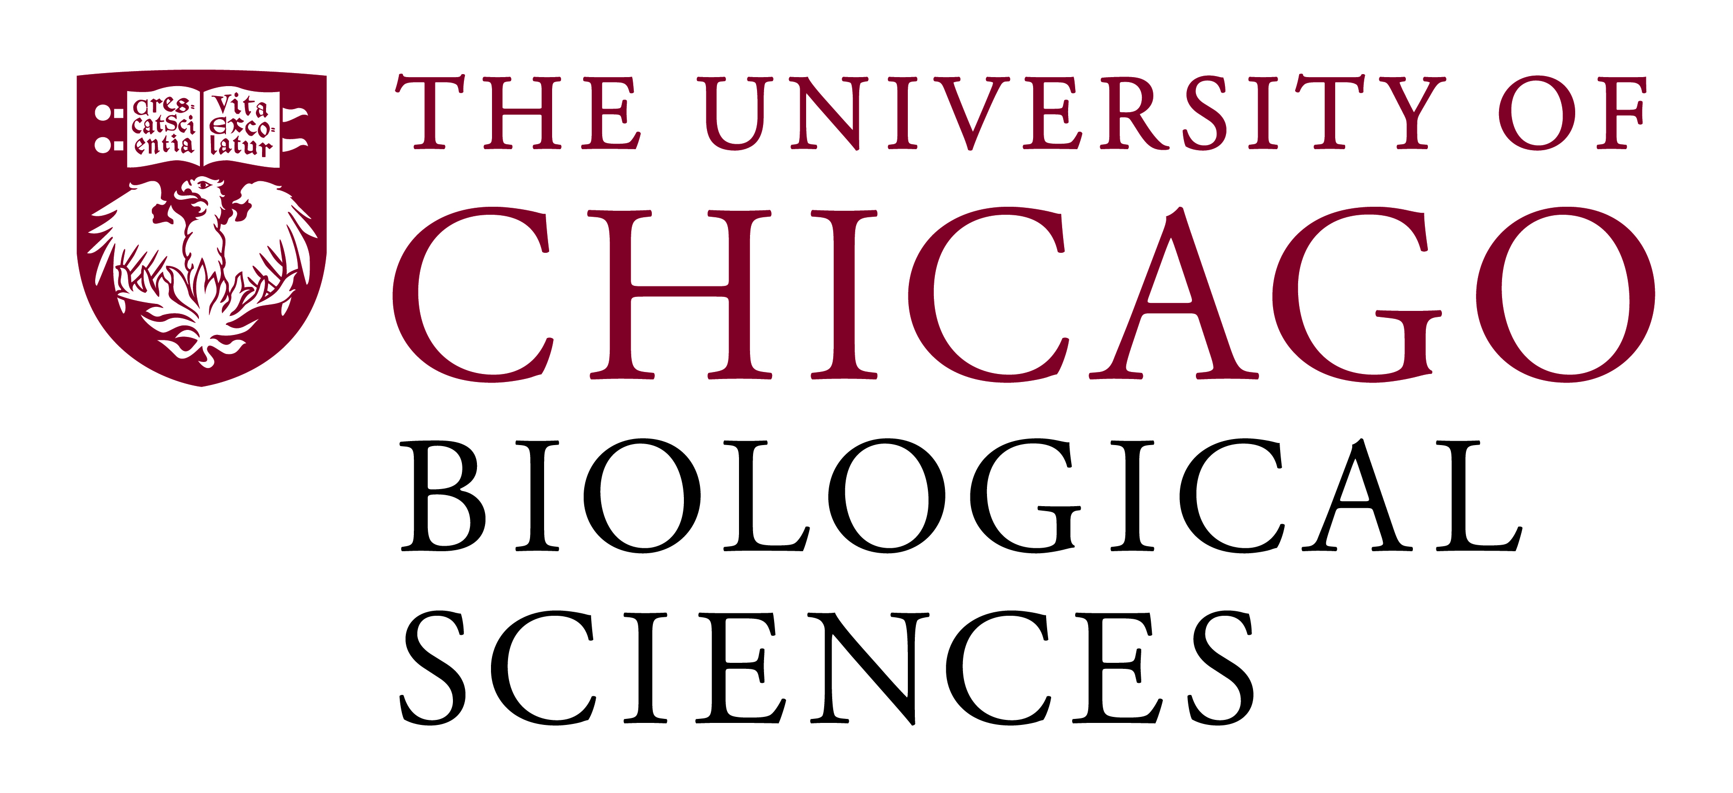

Postdoctoral (Scholar or Fellow) Position Open in the Ming Xu Lab.

Neurobiology of drug addiction
We are seeking a postdoctoral researcher to work on testing a novel gene therapy for treating drug abuse. We are interested in understanding mechanisms underlying drug addiction and in testing possible treatment approaches. We use behavioral, genetic, anatomical and molecular biological methods. Specifically, we should like to further test a novel skin stem cell-based method to deliver therapeutic genes to treat drug abuse and co-abuse in mouse models.
The postdoc will have the opportunity to work within an outstanding neuroscience research community with state-of-the-art facilities, and to interact closely with a substance abuse research focus group supported by an NIH training grant.
Qualified candidate should have a Ph.D in neuropharmacology or molecular and cellular biology, experience with behavioral pharmacology related to drug abuse is preferred. The candidate should also have demonstrated an ability to conduct independent research.
Motivated candidates should submit a curriculum vitae, a statement of research goals and names of three references to Dr. Ming Xu at mxu@dacc.uchicago.edu. Compensation in the Biological Sciences Division follows the NIH NRSA Stipend scale. Additional information on benefits and being a postdoc in the University of Chicago Biological Sciences Division can be found at bsdpostdoc.uchicago.edu.

