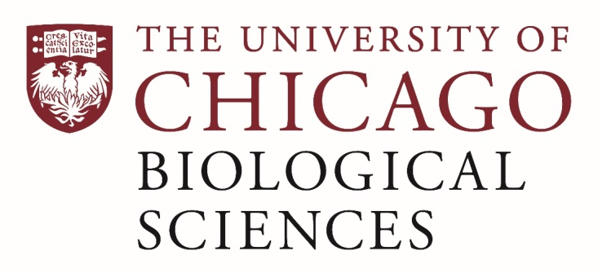

Postdoctoral Scholar Position Open in the Ross Lab.

[Anatomy and Evolutionary Biomechanics]
We are seeking a postdoctoral researcher to teach in the Human Body Course for first year medical students in the Pritzker School of Medicine and to work on research projects in evolutionary biomechanics. The Human Body course includes gross anatomy, histology and medical imaging delivered in lectures and laboratories. The evolutionary biomechanics research projects focus on musculoskeletal systems and emphasize feeding systems in mammals, but locomotor projects are also involved. Experience with neural data analysis, XROMM, finite element modeling and/or geometric morphometrics would be valuable.
The postdoc will have the opportunity to teach human anatomy to medical students in lecture and laboratory settings and to work with members of the Ross Lab and other labs in the Department of Organismal Biology and Anatomy. They will have access to XROMM, micro-CT and animal resources.
Applicants should have taught anatomy, preferably to medical students, with emphasis on dissection based instruction. They must have a PhD in hand at the start date (July 1, 2020), have demonstrated success at independent research, including collection and analysis of in vivo data, morphometric data, and or/ computational modeling.
Motivated candidates should submit a curriculum vitae and a statement of research goals to Dr. Callum Ross at rossc@uchicago.edu. Compensation in the Biological Sciences Division follows the NIH NRSA Stipend scale. Additional information on benefits and being a postdoc in the University of Chicago Biological Sciences Division can be found at bsdpostdoc.uchicago.edu.

