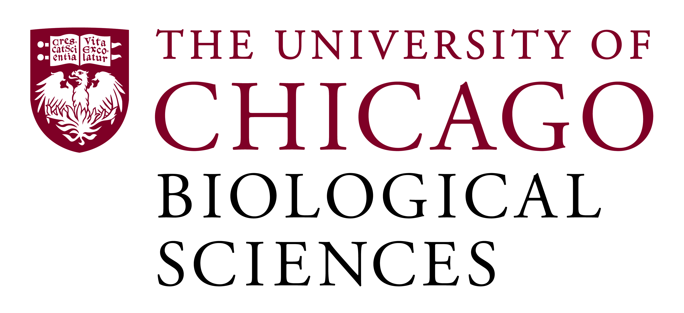

Pre- and Post-Doctoral Fellowship Position Open in Cardiovascular Training Program

[Area of expertise: Molecular Biology, Cell Biology and Animal models]
The Cardiovascular Sciences Training Grant welcomes applications for pre- (graduate) and post-doctoral programs. This opportunity is also available for selected M.D. graduates, who have prior basic research experience and who are interested in devoting at least 2 years to basic science research in the cardiovascular sciences. The T32 training grant supports trainees to work in the laboratories of one of 33 leading investigators, whose research are in the area of cardiovascular sciences. The trainers include faculty from Cardiology, Pathology, Genetics, Internal Medicine, Pediatrics, Neurology, Pharmacology, Physiology, Biochemistry, and Molecular Biology. The program emphasizes training in vascular and stem cell biology, atherosclerosis, cardiac development and pathophysiology, cellular cardiac electrophysiology, cardiac imaging, and cardiovascular metabolism, genetics, and epigenetics.
Candidates should be highly motivated and interested in pursuing a career in academic research. Pre-doctoral candidates must be a US citizen or Permanent Resident and be enrolled in a graduate program at the University of Chicago. Post-doctoral candidates must have a recent M.D., Ph.D., or M.D./Ph.D. with no more than 3 years of postdoctoral training and hold US citizenship or Permanent Residency.

Motivated candidates should submit a curriculum vitae and a statement of research goals to Professor James K. Liao at jliao@medicine.bsd.uchicago.edu. Compensation in the Biological Sciences Division follows the NIH NRSA Stipend scale. Additional information on benefits and being a postdoc in the University of Chicago Biological Sciences Division can be found at bsdpostdoc.uchicago.edu.

