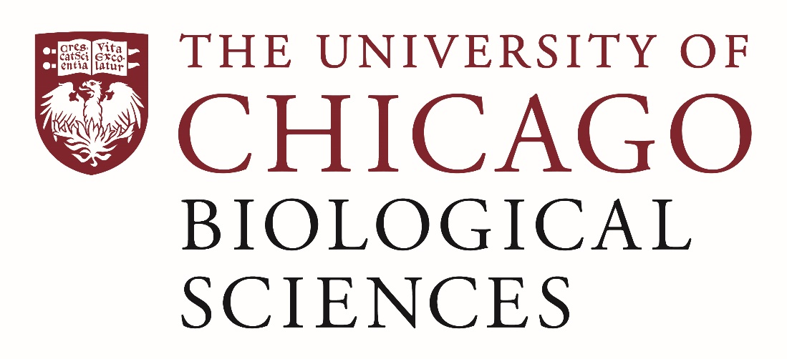

Postdoctoral Position Open in the Marlow Lab.

We are seeking a postdoctoral researcher in the area of epigenomics and chromatin biology. The Marlow lab investigates the evolution of gene regulatory mechanisms in metazoans with a specific focus on invertebrate systems. The recruited researcher will investigate the function of cell-type specific regulatory mechanisms through a combination of Hi-C based and chromatin-profiling approaches including ATAC-seq and ChIP-seq in cnidarians and basal deuterostomes. https://voices.uchicago.edu/marlowlab/ Experience with genetics, chromation biology and/or computational methods are highly encouraged. Familiarity with single-cell methods is a plus but not expected as training will be provided.
The postdoc will have the opportunity to work with a multi-disciplinary group of researchers and is expected to collaborate closely with other team members. The University of Chicago is a cutting-edge research environment that includes modern Genomics, Proteomics, and Light Microscopy core facilities, and a field research station, the Marine Biological Laboratory in Woods Hole, Massachusetts. Postdocs will have the opportunity to participate in the myCHOICE career mentoring program and will have regular training and outreach opportunities.
Candidates should have successfully defended a PhD in a relevant field of biology, computational biology or bioinformatics prior to the start of the position.
Motivated candidates should submit a curriculum vitae and a statement of research goals to Dr. Heather Marlow at hmarlow@uchicago.edu. Compensation in the Biological Sciences Division follows the NIH NRSA Stipend scale. Additional information on benefits and being a postdoc in the University of Chicago Biological Sciences Division can be found at bsdpostdoc.uchicago.edu.

