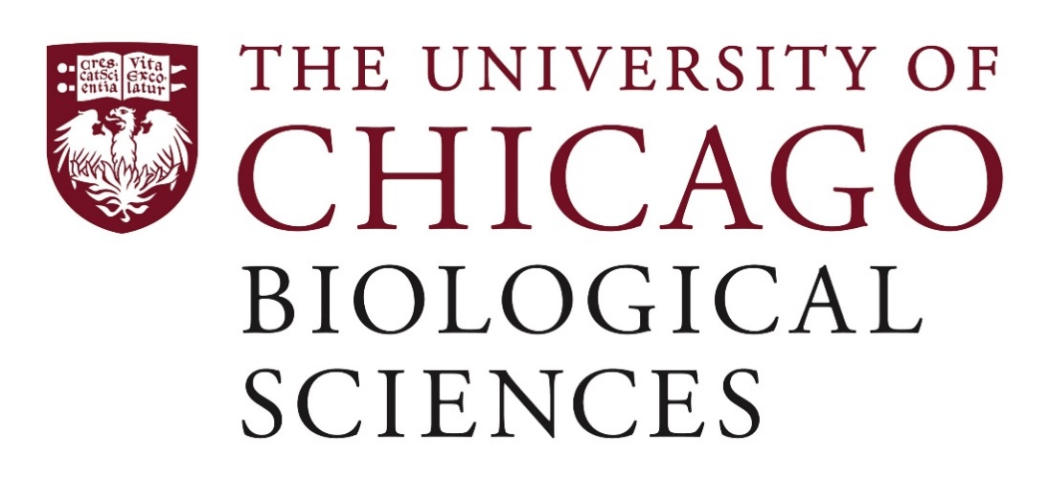
Postdoctoral Researcher – Microbiology in the Department of Surgery, Section of Colon and Rectal

Dr. Benjamin Shogan’s lab is looking to hire a Postdoctoral Researcher to assist the team in understanding the influence of the microenvironment and bacteria on the development of primary and recurrent colorectal cancer. The lab uses both in vitro and in vivo techniques, including murine models of colorectal surgery. The optimal candidate will have extensive experience in microbiology, including bacterial culture and identification, mutagenesis, bacterial phenotype analysis, generation of knockout mutants, and murine experiments.
Located in the Biological Sciences Division at the University of Chicago and affiliated with the Department of Surgery, Section of Colon and Rectal Surgery, the Shogan lab is seeking highly motivated candidates with expertise in areas such as:
- Microbiology (including bacterial culture and identification, mutagenesis, bacterial phenotype analysis, and generation of knockout mutants)
- Microbiome analysis, such as 16s rRNA
- DNA, RNA, protein isolations, transcriptomic analysis, Western blot, tissue cell culture, and tissue harvest/fixation and immunohistochemistry analysis
Motivated candidates should submit a curriculum vitae and a statement of research goals to Dr. Ben Shogan at bshogan@bsd.uchicago.edu. Compensation in the Biological Sciences Division follows the NIH NRSA Stipend scale. Additional information on benefits and being a postdoc in the University of Chicago Biological Sciences Division can be found at bsdpostdoc.uchicago.edu.

