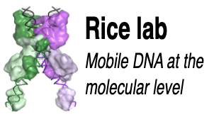
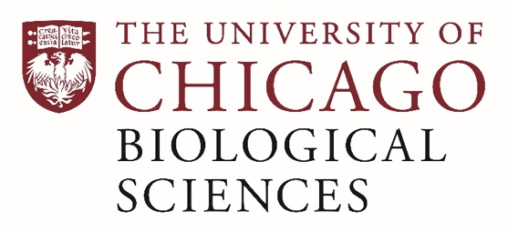

Postdoctoral Position open in the Rice Lab.

Mechanism, Engineering, and Structural Biology of Large Serine Integrases
A postdoctoral position is available immediately the laboratory of Dr. Phoebe Rice.

Large serine integrases (LSIs; derived from lysogenic phages) mediate precise site-specific DNA recombination (integration, excision, or inversion), leaving not a single nick in the DNA backbone. Control of LSI directionality is uniquely simple. The integrase itself catalyzes phage insertion, but not the reverse (excision) reaction. Excision requires a 2nd protein called a recombination directionality factor (RDF), that binds its cognate integrase and alters its conformation in an unknown manner that somehow inhibits integration and activates excision. LSI-RDF pairs can catalyze the insertion of large payloads without relying on host DNA repair (unlike CRISPR-Cas-based systems) and can scarlessly and controllably reverse those insertions (unlike any other system).

This project seeks to (1) understand, through cryo electron microscopy and biochemistry, how an RDF interacts with its cognate integrase to control the reaction direction; (2) through bioinformatics and protein engineering, eliminate the current bottleneck in identifying cognate RDFs for individual LSIs and (3) enhance the usefulness of RDFs by engineering new control mechanisms into them. The project is funded by a new large, collaborative NSF + UKRI/BBSRC award to the Rice (https://voices.uchicago.edu/phoebericelab/) and Olorunniji (Olorunniji lab) labs.

Successful applicants will have a Ph.D. or MD/PhD in the broadly defined fields of Biochemistry, Biophysics, and/or Molecular Biology. Experience with the tools of structural biology and / or nucleic acid biochemistry is preferred. Applicants should be eager to learn new skills and systems, and should have effective communication, teamworking and problem-solving skills.

The postdoctoral fellow will be part of the vibrant local structural biology, protein engineering and microbiology communities, with access to our state-of-the-art electron microscopy facilities https://voices.uchicago.edu/advancedem/. Mentorship will be tailored to the fellow’s goals and can include, for instance, participation in the University’s MyChoice career development program and guided mentorship of diverse undergraduate students.

To apply, email Dr. Rice at PRice@uchicago.edu and include a cover letter explaining relevant work experience and interest in this position, a CV and the contact information of 2-3 references.

Compensation in the Biological Sciences Division follows the NIH NRSA Stipend scale. Additional information on benefits and being a postdoc in the University of Chicago Biological Sciences Division can be found at https://bsdpostdoc.uchicago.edu/.

The University of Chicago is an Affirmative Action/Equal Opportunity/Disabled/Veterans Employer and does not discriminate on the basis of race, color, religion, sex, sexual orientation, gender identity, national or ethnic origin, age, status as an individual with a disability, protected veteran status, genetic information, or other protected classes under the law. For additional information please see the University's Notice of Nondiscrimination at: www.uchicago.edu/non-discrimination . Job seekers in need of a reasonable accommodation to complete the application process should call +1 773-834-6693 or email hmcguinn@bsd.uchicago.edu with their request.

