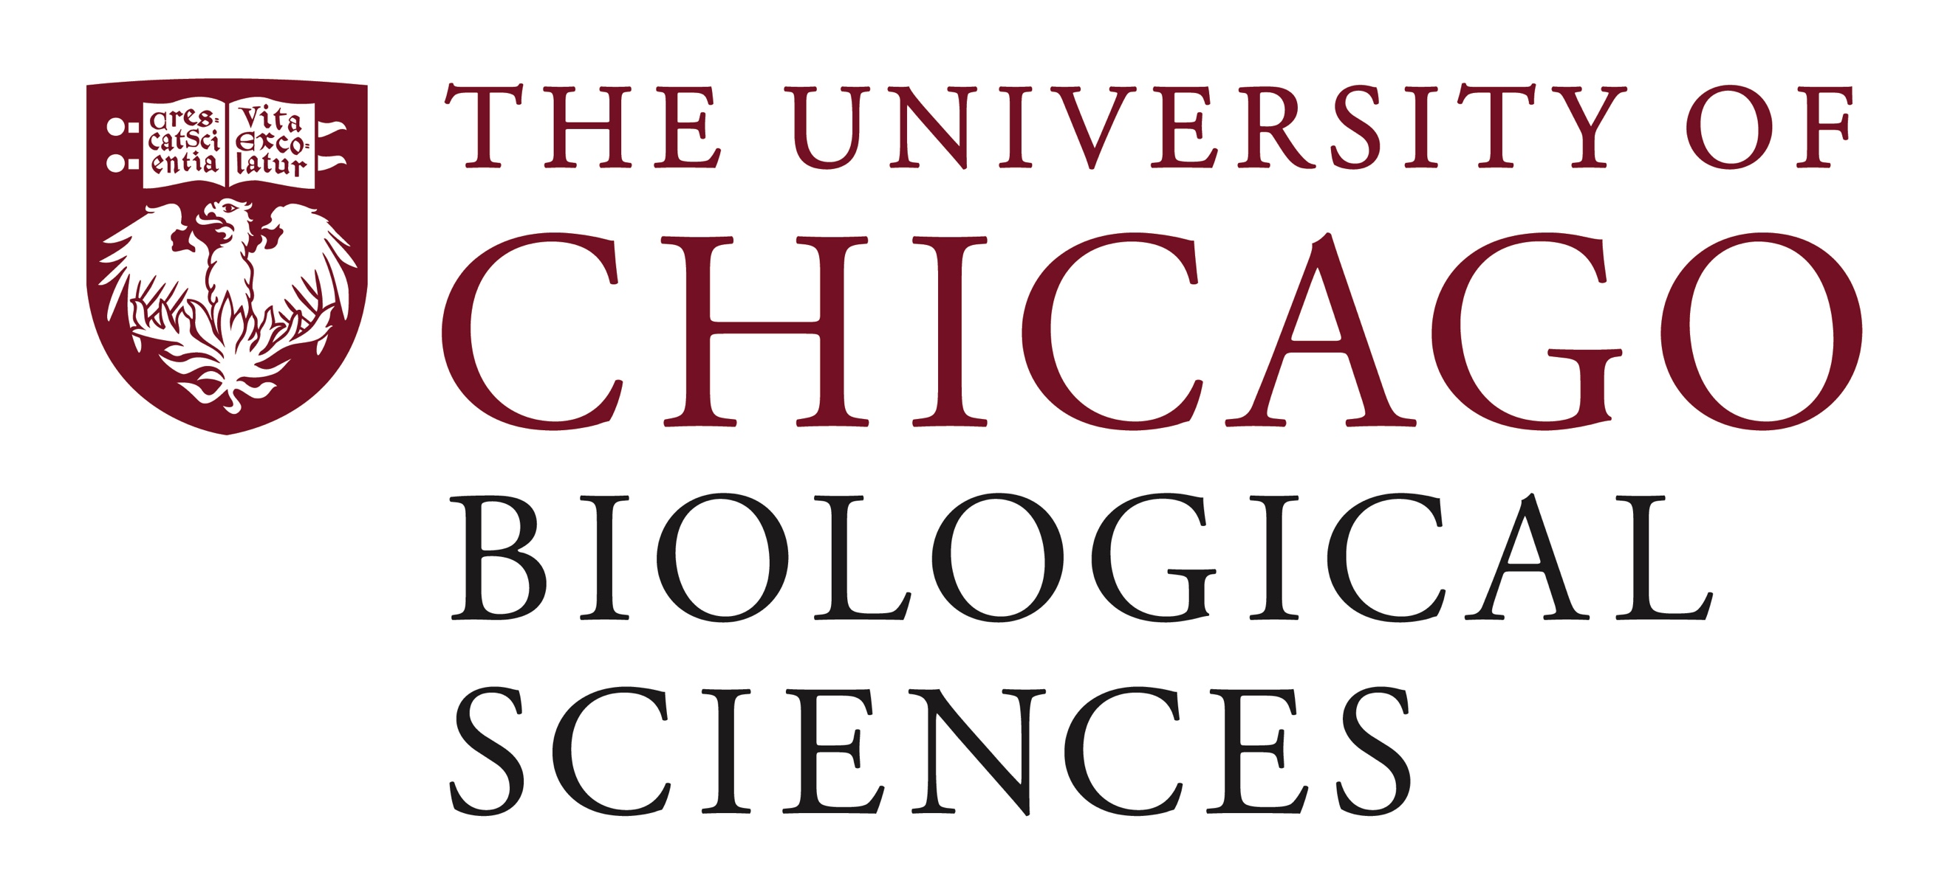

Postdoctoral Fellow Position Open in the Department of Radiology

MRI of Prostate Cancer
We are seeking a postdoctoral fellow interested in magnetic resonance imaging (MRI) of prostate cancer. The research focuses on development of new MRI methods for diagnosis of prostate cancer, including diffusion imaging, quantitative DCEMRI, quantitative T2 mapping, and hybrid multidimensional MRI. The MRI Research Center is equipped with two state-of-the-art Philips 3T scanners with specialized detectors for prostate imaging. In addition, there is a 9.4 Tesla Bruker scanner for studies of small animal models of cancer. State-of-the-art computing resources are available in the Department of Radiology and in the University’s Research Computing Center.
The postdoc will have the opportunity to learn all phases of biomedical MRI including data acquisition, pulse programming, quantitative data analysis, and correlation of MRI with histology. They will join a large and successful interdisciplinary research group that includes medical physicists, MRI technologists, clinical research coordinators, programmers, Radiologists, Surgeons, Oncologists, and Pathologists. This is an ideal opportunity to work in an interdisciplinary environment to learn translational MRI. The selected applicant will be mentored by Dr. Aytek Oto, Professor and Chair of Radiology, and Director of the Grossman Center for Prostate Cancer Imaging and Dr. Greg Karczmar, Professor of Radiology and Medical Physics, Director of MR Research. Dr. Oto and Dr. Karczmar have a strong record of preparing post-doctoral fellows for successful academic careers.
This position requires a Ph.D. in Physics, Medical Physics, Physical Chemistry, Biophysics, Electrical Engineering, Bioengineering, or a related discipline. An understanding of NMR or MRI physics and instrumentation is preferred but not required. A background in diffusion NMR or MRI, quantitative T2 mapping and/or DCEMRI is helpful but not required. Experience with Matlab is very helpful. Applicants with strong physical or biophysical sciences background are strongly encouraged to apply. The candidate must be highly motivated, have excellent written and verbal communication skills, and enthusiasm to work in a multi-disciplinary team. We frequently recruit and train people who have a strong background in the physical sciences but little or no NMR or MRI experience.
Motivated candidates should submit a curriculum vitae to Monique Shelton, Senior Academic Affairs Professional at mshelton@bsd.uchicago.edu. If you have any questions regarding the position, please contact Dr. Greg Karczmar at gskarczm@uchicago.edu. Compensation in the Biological Sciences Division follows the NIH NRSA Stipend scale. Additional information on benefits and being a postdoc in the University of Chicago Biological Sciences Division can be found at bsdpostdoc.uchicago.edu.
The City of Chicago, the local neighborhood of Hyde Park, and the University are highly diverse and inclusive communities where people with a range of opinions and backgrounds come together. Women’s rights to comprehensive health care are strongly supported. The research group encourages vigorous discussion and debate and input of all members of the group is respected and valued.
The University of Chicago is an Affirmative Action/Equal Opportunity/Disabled/Veterans Employer and does not discriminate on the basis of race, color, religion, sex, sexual orientation, gender identity, national or ethnic origin, age, status as an individual with a disability, protected veteran status, genetic information, or other protected classes under the law. For additional information please see the University's Notice of Nondiscrimination at: https://www.uchicago.edu/about/non_discrimination_statement/. Job seekers in need of a reasonable accommodation to complete the application process should call 773-702-6154 or email jhlavaty@radiology.bsd.uchicago.edu with their request.

