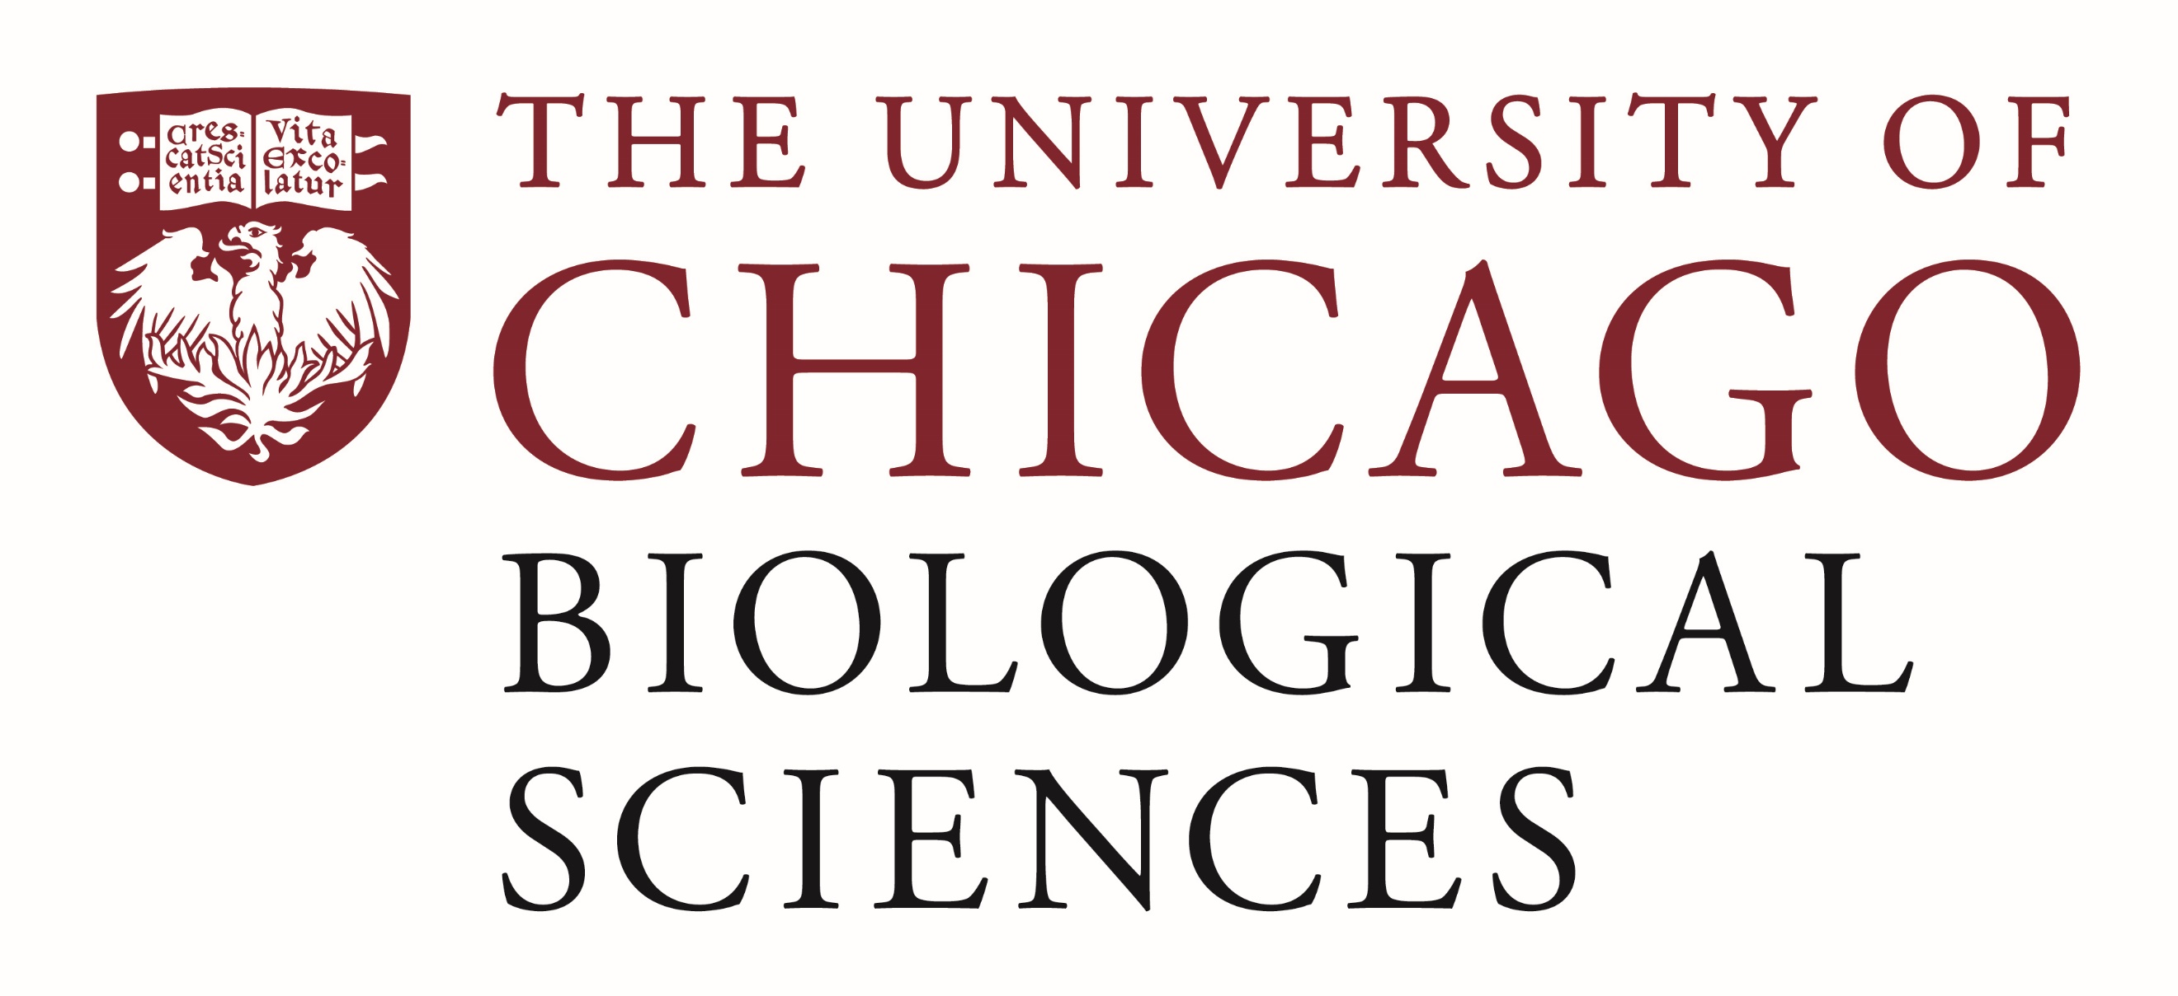

Postdoctoral Position Open with the Cortical Bionics Research Group - Chicago

Area of expertise:
We are seeking a postdoctoral researcher to work in sensorimotor neuroscience with brain-computer interfaces (BCI) and peripheral nerve interfaces.
The research projects will focus on dexterous control of a robotic hand through neural recordings and restoration of sensation to neural stimulation. We specialize in generating biomimetic interactions with the peripheral and central nervous system to provide strong and intuitive sensory feedback and motor control. The work covers both a basic science understanding of how the nervous system naturally processes sensation and the translational advances that can be made based on this understanding. The BCI project is part of the Cortical Bionics Research Group multi-site clinical trial, which includes University of Pittsburgh and Northwestern University. Peripheral nerve stimulation for users of an osseointegrated prosthetic arm will be done in collaboration with the Shirley Ryan AbilityLab. These projects are led by John Downey and Charles Greenspon.
Experience:
- Background in Systems Neuroscience, Computational Neuroscience, Neuroengineering, or a similar field.
- Strong coding and data analysis abilities.
- A strong ability to work in a collaborative environment.
Responsibilities:
- Develop and implement experiment plans with human subjects.
- Analyze and present results in an impactful way.
- Help mentor students working on related projects.
This is a fixed-term, full-time position available for two years in the first instance, to start in (or shortly after) June 2024. There is possibility for extension, subject to project status and funding.
If you are interested, please apply by email to John Downey (johndowney@uchicago.edu) with the subject line “Postdoc Application: [Full Name]”. Please include (1) Curriculum Vitae (2) covering letter (max. 2 pages), including a description of research experience and interests and (3) names and contact details of three references
Review of applications will begin on February 15th and will continue until a suitable candidate is selected.
Compensation in the Biological Sciences Division follows the NIH NRSA Stipend scale. Additional information on benefits and being a postdoc in the University of Chicago Biological Sciences Division can be found at bsdpostdoc.uchicago.edu.

