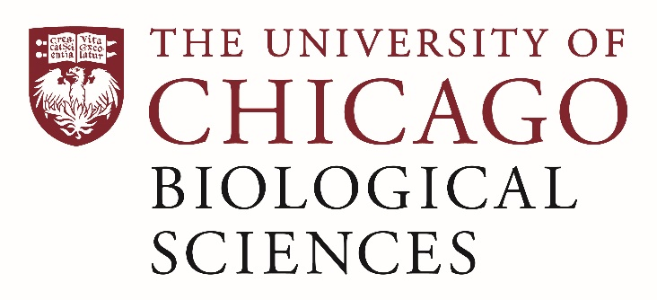

Postdoctoral Position open in the Sisodia Lab.

Biochemistry and Molecular Neurobiology
The Department of Neurobiology is seeking an enthusiastic, organized, and self-motivated Postdoctoral Fellow with training in biochemistry and molecular neurobiology. The Postdoctoral Fellow will participate in studies that assess the role of the gut microbiome in amyloid plaque pathology and neuroinflammation in mouse models of Alzheimer’s disease under the direction of Dr. Sangram Sisodia. The postdoc is expected to be able to design and perform research experiments, as well as summarize data and perform statistical analyses.
A MD, Ph.D. or MD/PhD in Neurobiology, biochemistry and neuroscience is preferred. Laboratory experience in molecular biology absolutely is essential. Mentorship by the principal investigator will be used for training and promoting career development of the candidate, and the scholar will also have the opportunity to collaborate with other basic and clinical scientists.. Job duties include;
Plans, directs and conducts studies of transgenic mice, human iPS-derived microglia and genetic modifications using CRISPR-based methods
Acquires and maintain competency in routine techniques including but not limited to: isolation and flow cytometry sorting of immune cells, Western blotting, immunoprecipitation, plasmid preparation, cell transfection and infection, immunohistochemistry and immunofluorescence.
Performs statistical analyses.
Summarizes research findings and publishes results in research journals.
Assists with grant proposal writing and progress reports.
Assists with laboratory operations.
Supports supervision of research staff, including graduate and undergraduate students.

Motivated candidates should submit a curriculum vitae and a statement of research goals to Dr. Sangram Sisodia at ssisodia@bsd.uchicago.edu. Compensation in the Biological Sciences Division follows the NIH NRSA Stipend scale. Additional information on benefits and being a postdoc in the University of Chicago Biological Sciences Division can be found at bsdpostdoc.uchicago.edu.

